# Resize Ad

## Goal of Ad

This ad will test that the MRAID v2 container is properly supporting basic resize ads. This particular creative sets allowOffscreen to false so that the creative should always remain onscreen and expand from the relative banner position. Unless the screen size is smaller than 300x250 it should not error out on resize.

## This Creative Tests:

**MRAID Methods Tested:**

* mraid.addEventListner
* mraid.close
* mraid.createCalendarEvent
* mraid.getDefaultPosition
* mraid.getState
* mraid.open
* mraid.playVideo
* mraid.removeEventListener
* mraid.resize
* mraid.setResizeProperties
* mraid.storePicture
* mraid.supports

**MRAID Events Watched:**

* error
* ready
* sizeChange
* stateChange

**JavaScript Events Watched:**

* orientationchange

**Other:**

* console.log

## Behavior of Ad

**Initial/Default State**

* This ad should render as a 320x50 banner in either landscape or portrait.
* Below are sample screenshots of this ad displayed at a top and bottom placement in portrait orientation and at a top placement in landscape orientation.

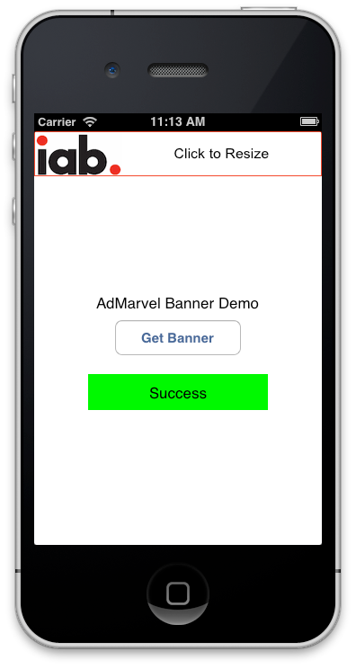 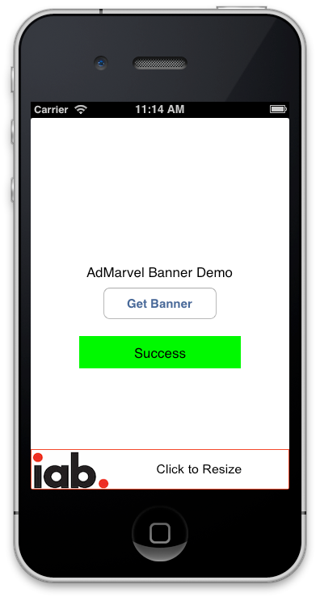

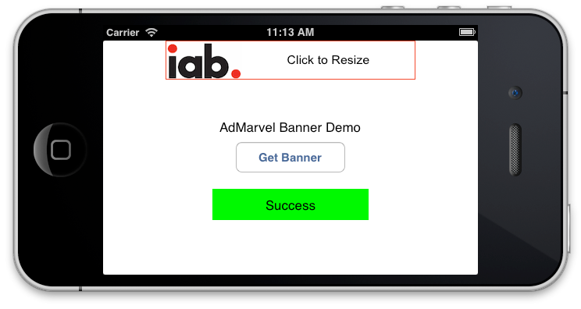

**User Clicks Banner Ad**

* When clicked this ad attempts to resize to a 320x250 non-modal ad. The resize properties are setup so that that the width is 320, height is 250, the offsetX is 0, offsetY is 0 and allowOffscreen is false. This means that the ad should resize down if there is space but will resize to fit on screen if there isn’t. So a banner on the bottom of the app for example would resize up.
* There should be a log message for the default position before resizing just to validate the SDK is returning that information correctly.
* Below are sample screenshots of this ad having expanded from both a top and bottom placement in portrait orientation and a top placement in landscape orientation.

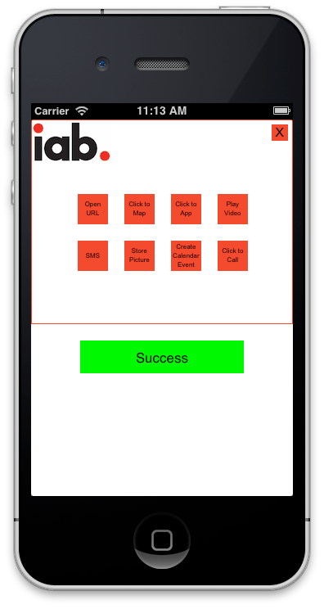 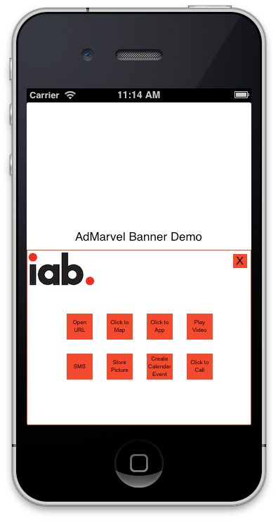

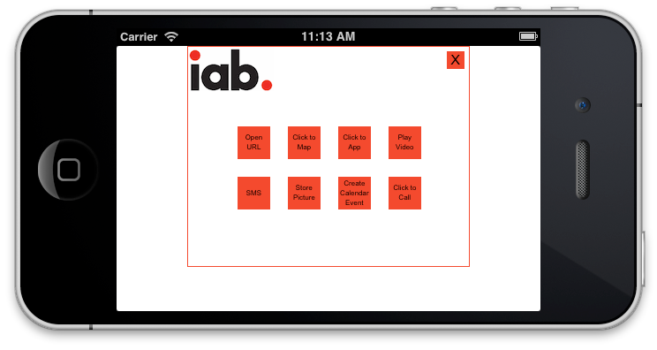

**User Rotates Resized Ad**

* Since resize ads can’t lock orientation the ad just closes itself when it gets an orientationchange event to prevent any unexpected behavior.

**User Clicks Resized Ad Buttons**

* Open URL – This uses the MRAID open method to launch the IAB MRAID website.
* Click to Map – This uses the MRAID open method to launch a link to IAB NY office in Google maps.
* Click to App – This uses the MRAID open method. For iOS this should launch the app store for the IAB app. For Android this should take you to the market for the IAB app. For other OS it should print a message saying there is no supported app link available.
* Play Video – This should play an IAB video using the MRAID playVideo method.
* SMS – This first uses the MRAID supports method to check if sms is supported. If not it logs a message saying it isn’t supported. If so then it uses the MRAID open method to launch a sms link.
* Store Picture – This first uses the MRAID supports method to check if storePicture is supported. If not it logs a message saying it isn’t supported. If so then it uses the MRAID storePicture method to store a IAB logo. The ad also uses the error event listener to log a message if the user cancels the request.
* Create Calendar Event – This first uses the MRAID supports method to check if createCalendarEvent is supported. If not it logs a message saying it isn’t supported. If so then it uses the MRAID createCalendarEvent method to store a sample calendar entry as shown in MRAID spec. The ad also uses the error event listener to log a message if the user cancels the request.
* Click to Call – This first uses the MRAID supports method to check if tel is supported. If not it logs a message saying it isn’t supported. If so then it uses the MRAID open method to launch a tel link.

**User Closes Ad**

* The ad should return to its starting banner placement. The top right 50x50 are should all be clickable due to the required MRAID container supplied close area.

## MRAID 2 Compliance Checklist

A container/SDK running this test creative must exhibit these behaviors to prove MRAID compliance.

* Ad resizes relative to the banner position. It should resize down unless there is not enough space in which case it should resize up to fit.
* The various click actions should respond as described above.
* On close the ad should return to its original position.

## URL For this Creative

http://mraid.iab.net/compliance/units/resize.txt

## Additional Notes

This ad calls a common logging method called logMRAIDMessage. This currently is coded to call console.log. However if you are testing in an environment where console.log does not work please change this to your desired logging method so you can see any informational logs this ad prints.

## Acknowledgement

The IAB is grateful for the assistance of Adam Schuetz, of AdMarvel, who created this IAB MRAID Test Ad. Please direct any questions about the creative or the associated documentation to the IAB at mobile@iab.net.